The TILKIT Framework and Process - the infographic
From Venice
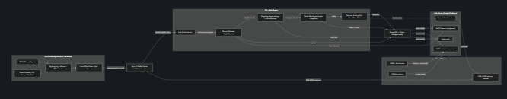
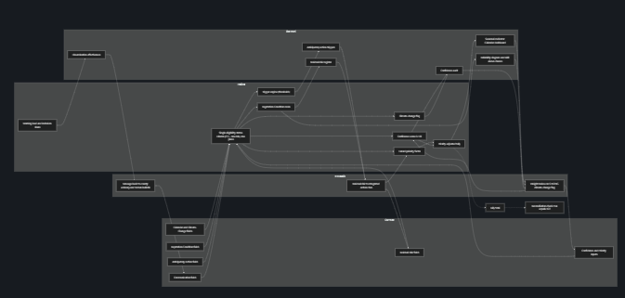
From ChatGPT
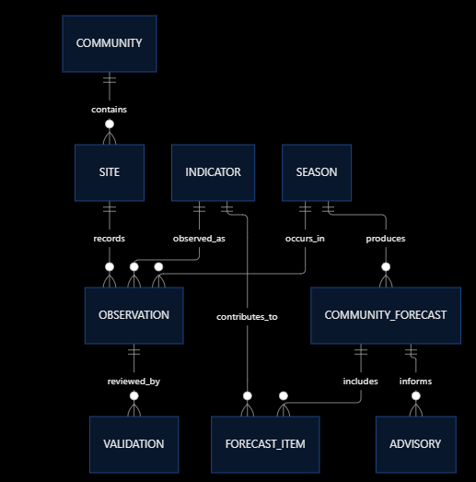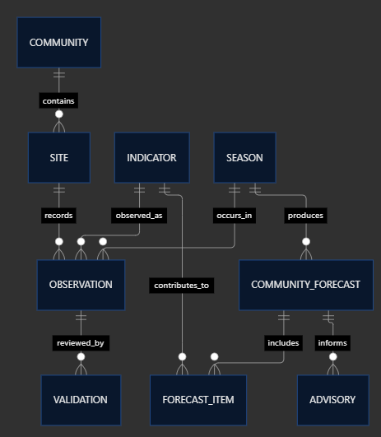
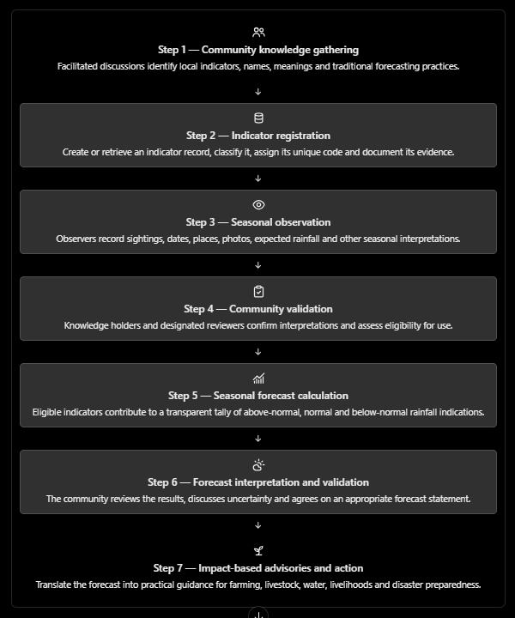
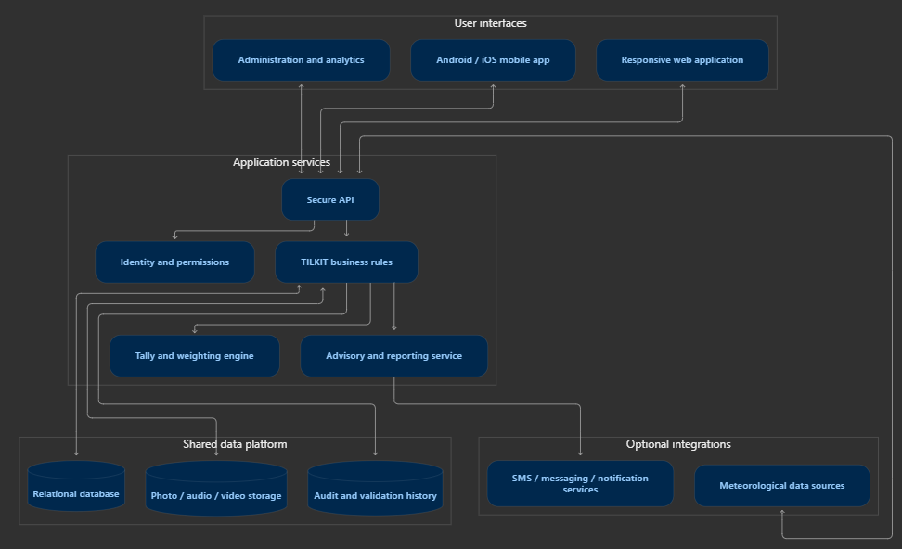

From Claude

The TILKIT process
TILKIT runs as a repeating seasonal cycle: observe, validate, forecast, integrate, communicate, act, verify and learn. Each season builds on the evidence of the last, so the community forecast grows more reliable over time.
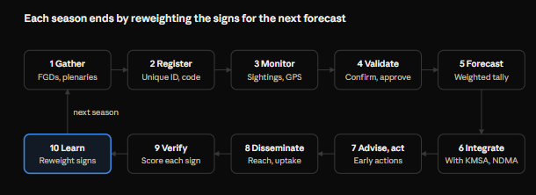
Seasonal lifecycle and record states
